Hollands

* Uitvaartbakfiets
* Broodje ham/kaas of krentenbol
* Broodje haring
* Broodje kroket
* [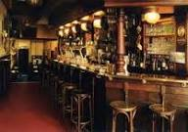](http://www.google.nl/imgres?q=kroeg&um=1&hl=nl&sa=N&rlz=1T4AURU_nlNL498NL500&biw=1280&bih=576&tbm=isch&tbnid=sNM88tzvaq07YM:&imgrefurl=http://home.hccnet.nl/w.bekkers/fotonewslog0111.htm&docid=bJPWRQXNRmf4fM&imgurl=http://home.hccnet.nl/w.bekkers/images/fotonews-nov/kroeg.jpg&w=260&h=183&ei=6QWAULKeO8XJsgaEy4HYAg&zoom=1&iact=rc&dur=156&sig=109992814445244861312&page=4&tbnh=121&tbnw=166&start=58&ndsp=26&ved=1t:429,r:21,s:58,i:381&tx=81&ty=65)Kaas met mosterd en worst
* Biertje
* Hollandse zangers
* Friet

[](http://www.google.nl/imgres?q=rouw+grafwerk&start=149&hl=nl&tbo=d&biw=1920&bih=985&tbm=isch&tbnid=_gPKTr3zmKEQHM:&imgrefurl=http://www.vdzwaag.nl/Alles-over-de-uitvaart/De-uitvaart/Rouwbloemen/toonitem/54234/54334/Biedermeier-witte-rozen.html&docid=k0hoRENIGwWiQM&imgurl=http://www.vdzwaag.nl/wisexs/GetImage.php?id=2466&w=320&w=320&h=267&ei=-WftUPuHEoLU0QWY-IC4Cg&zoom=1&iact=hc&vpx=1063&vpy=415&dur=8799&hovh=205&hovw=246&tx=128&ty=120&sig=116823345645395816220&page=3&tbnh=155&tbnw=194&ndsp=67&ved=1t:429,r:55,s:100,i:169)[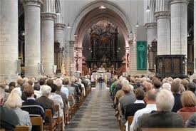](http://www.google.nl/imgres?q=spaanse+uitvaart&hl=nl&tbo=d&biw=1024&bih=673&tbm=isch&tbnid=Oay8ChgAkygPjM:&imgrefurl=http://www.hbvl.be/limburg/maasmechelen/eerste-leken-klaar-met-cursus-voor-uitvaart.aspx&docid=5s9b3ooi3zDpAM&imgurl=http://s1.hbvl.be/ahimgpath/assets_img_hbvl/2010/02/10/906245/eerste-leken-klaar-met-cursus-voor-uitvaart-id1030802-620x415.jpg&w=620&h=415&ei=6O-9UKiLLIWWyAHtvYDIBg&zoom=1&iact=hc&vpx=328&vpy=358&dur=225&hovh=184&hovw=275&tx=113&ty=149&sig=116823345645395816220&page=2&tbnh=150&tbnw=222&start=19&ndsp=19&ved=1t:429,r:21,s:0,i:148)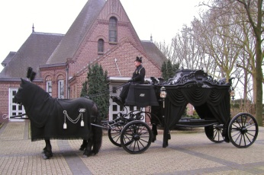



[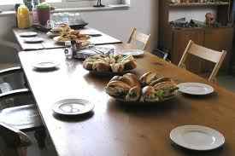](http://www.google.nl/imgres?q=broodjes+met+soep&start=241&um=1&hl=nl&sa=N&qscrl=1&rlz=1T4AURU_nlNL498NL500&biw=1280&bih=576&tbm=isch&tbnid=1X42B0qRlHQ8nM:&imgrefurl=http://www.samscustomshop.nl/nl/pagemanager/workshops.html&docid=5b1bCeg2yHuf-M&imgurl=http://www.samscustomshop.nl/index.php?mod=mediamanager&com=getFile&id=158&w=1827&h=1219&ei=k_x_UMymNs7BtAa6oYHoCA&zoom=1&iact=hc&vpx=86&vpy=2&dur=281&hovh=183&hovw=275&tx=157&ty=108&sig=109992814445244861312&page=11&tbnh=123&tbnw=170&ndsp=24&ved=1t:429,r:18,s:241,i:223)[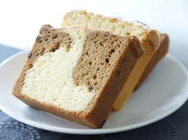](http://www.google.nl/imgres?q=plakken+cake&um=1&hl=nl&gbv=2&biw=1024&bih=673&tbm=isch&tbnid=m5uCVMDlbD60FM:&imgrefurl=http://www.hetbakkertje.nl/index.php/cake-gebak/cappuccinocake-plak.html&docid=iSzy_MKf6GdQKM&imgurl=http://www.hetbakkertje.nl/media/catalog/product/cache/1/image/9df78eab33525d08d6e5fb8d27136e95/p/4/p4191780.jpg&w=802&h=601&ei=yIl9T7GWJOab1AWO1szMDQ&zoom=1&iact=hc&vpx=553&vpy=194&dur=1256&hovh=194&hovw=259&tx=170&ty=105&sig=116015458144103310360&page=4&tbnh=144&tbnw=208&start=53&ndsp=16&ved=1t:429,r:10,s:53,i:210)[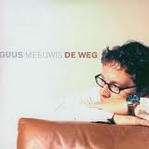](http://www.google.nl/imgres?q=guus+meeuwis+de+weg&um=1&hl=nl&sa=N&rlz=1T4AURU_nlNL498NL500&biw=1280&bih=576&tbm=isch&tbnid=Q5dlDc-DjAlkEM:&imgrefurl=http://swisscharts.com/showitem.asp?interpret=Guus+Meeuwis&titel=De+weg&cat=s&docid=hfsW037C0IQ8bM&imgurl=http://hitparade.ch/cdimag/guus_meeuwis-de_weg_s.jpg&w=200&h=200&ei=Wv9_ULrXHoXxsgbrp4GYCw&zoom=1&iact=hc&vpx=881&vpy=69&dur=641&hovh=160&hovw=160&tx=100&ty=108&sig=109992814445244861312&page=1&tbnh=116&tbnw=117&start=0&ndsp=22&ved=1t:429,r:5,s:0,i:86)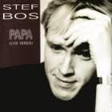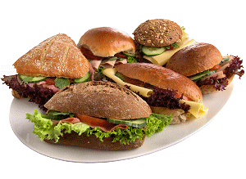[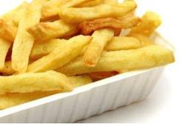](http://www.google.nl/imgres?q=friet&um=1&hl=nl&sa=N&qscrl=1&rlz=1T4AURU_nlNL498NL500&biw=1280&bih=576&tbm=isch&tbnid=mkuL0qiKeszC3M:&imgrefurl=http://www.dutchcowgirls.nl/social/1215&docid=MxaZbV8RS2G_CM&imgurl=http://www.dutchcowgirls.nl/images/upload/patat2.jpg&w=308&h=209&ei=ov5_UKuOBMjetAaUioDAAQ&zoom=1&iact=hc&vpx=402&vpy=290&dur=1750&hovh=167&hovw=246&tx=125&ty=86&sig=109992814445244861312&page=3&tbnh=122&tbnw=170&start=37&ndsp=24&ved=1t:429,r:20,s:37,i:323)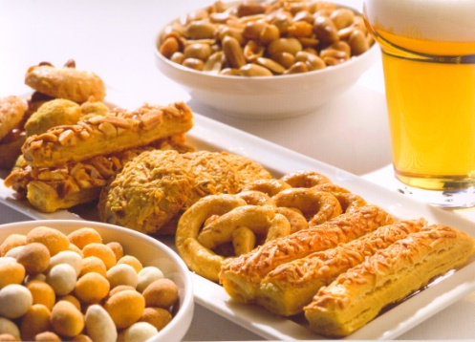[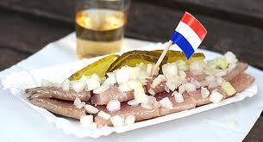](http://www.google.nl/imgres?q=haring&um=1&hl=nl&rlz=1T4AURU_nlNL498NL500&biw=1280&bih=576&tbm=isch&tbnid=lNQqnFRiKbPCmM:&imgrefurl=http://blog.easytobook.com/tips/street-food-around-the-world/&docid=8WjZzOWz3rASpM&imgurl=http://blog.easytobook.com/wp-content/uploads/2012/03/haring2.jpg&w=500&h=271&ei=CwCAUO-XLI3JsgbWh4DoBw&zoom=1&iact=hc&vpx=243&vpy=274&dur=7125&hovh=165&hovw=305&tx=185&ty=105&sig=109992814445244861312&page=4&tbnh=89&tbnw=165&start=63&ndsp=25&ved=1t:429,r:20,s:63,i:402)[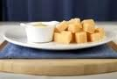](http://www.google.nl/imgres?q=kaas+met+mosterd&start=104&um=1&hl=nl&qscrl=1&rlz=1T4AURU_nlNL498NL500&biw=1280&bih=576&tbm=isch&tbnid=vCRl-_zRkNy00M:&imgrefurl=http://nl.123rf.com/photo_7929589_close-up-van-nederlandse-kaas-en-mosterd.html&docid=seJVP4BfSYosCM&imgurl=http://us.cdn3.123rf.com/168nwm/charlottelake/charlottelake1007/charlottelake100700007/7458453-nederlands-behandelen-van-kaas-met-pittige-mosterd.jpg&w=168&h=113&ei=wf1_UKeKMYTIsgaFqYGQAQ&zoom=1&iact=hc&vpx=405&vpy=317&dur=234&hovh=90&hovw=134&tx=107&ty=37&sig=109992814445244861312&page=5&tbnh=90&tbnw=134&ndsp=27&ved=1t:429,r:2,s:104,i:101)[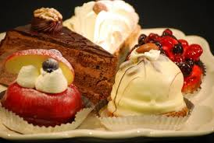](http://www.google.nl/imgres?q=gebak&num=10&hl=nl&tbo=d&biw=1920&bih=985&tbm=isch&tbnid=qbzyACfMCaZ01M:&imgrefurl=http://www.boonstrabanket.nl/assortiment/gebak&docid=Xbbs9eYT2_2NrM&imgurl=http://www.boonstrabanket.nl/photos/Gebak/60_big.jpg&w=640&h=429&ei=bnftUMrkJ6mJ0AXLhoGQBg&zoom=1&iact=hc&vpx=2&vpy=687&dur=1158&hovh=184&hovw=274&tx=149&ty=120&sig=116823345645395816220&page=1&tbnh=148&tbnw=224&start=0&ndsp=59&ved=1t:429,r:49,s:0,i:281)[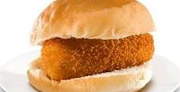](http://www.google.nl/imgres?q=kroket&start=234&um=1&hl=nl&qscrl=1&rlz=1T4AURU_nlNL498NL500&biw=1280&bih=576&tbm=isch&tbnid=Xm_BdETUMQfryM:&imgrefurl=http://www.metronieuws.nl/nieuws/van-dobben-kroket-uit-diepvries-supermarkt/IWIlin!pZDyqIzn1an2THuUHPvm9A/&docid=otzaom3NExIHoM&imgurl=http://www.metronieuws.nl/_internal/gxml!0/4dntvuhh2yeo4npyb3igdet73odaolf$p5t199kwrxdjjg4ewq7eamuoq6idz2h/novum.jpeg&w=567&h=291&ei=H_5_UKbHDs7VsgbRvoCoDQ&zoom=1&iact=rc&dur=63&sig=109992814445244861312&page=11&tbnh=86&tbnw=167&ndsp=28&ved=1t:429,r:14,s:234,i:204&tx=103&ty=64)[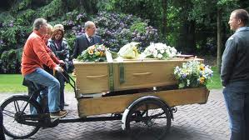](http://www.google.nl/imgres?q=uitvaart+bakfiets&um=1&hl=nl&sa=N&rlz=1T4AURU_nlNL498NL500&biw=1280&bih=576&tbm=isch&tbnid=lYbQfPJXMDyGkM:&imgrefurl=http://www.yarden.nl/ideeen-overzicht/thema/detail-inspiratie/op-de-bakfiets&docid=8JXFsM_NpHxflM&imgurl=http://www.yarden.nl/template/RootSite/binaryresource/assets/inspiration/133-3347_IMG-.jpg&w=648&h=365&ei=7gCAUOnrE8bvsgai-YCoAQ&zoom=1&iact=hc&vpx=66&vpy=151&dur=969&hovh=168&hovw=299&tx=159&ty=98&sig=109992814445244861312&page=1&tbnh=87&tbnw=155&start=0&ndsp=18&ved=1t:429,r:0,s:0,i:71)